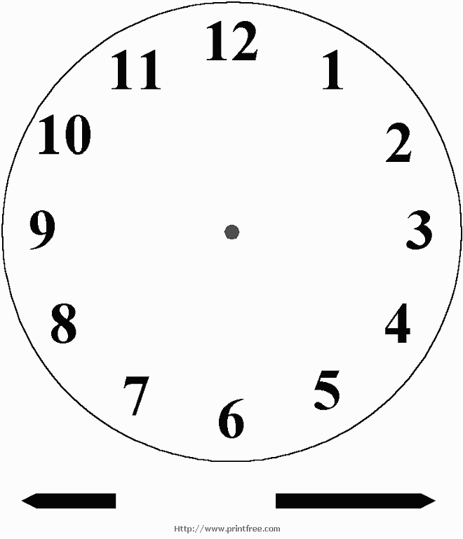

turtle.WMF

When the hare makes it all the way around the clock, he says “**O’clock!**” This is to let the tortoise know, he’s finished and that the tortoise should be exactly on the hour.

bunny.WMF

